TITLE

Author 1
Name Surname1 Surname2
Brief curriculum (2 lines). Position, Department, University or Institution. City (Country).
E-mail:
Author 2
Name Surname1 Surname2
Brief curriculum (2 lines). Position, Department, University or Institution. City (Country).
E-mail:
Author 3
Name Surname1 Surname2
Brief curriculum (2 lines). Position, Department, University or Institution. City (Country).
E-mail:
Author 4
Name Surname1 Surname2
Brief curriculum (2 lines). Position, Department, University or Institution. City (Country).
E-mail:

ABSTRACT

Typography: Times New Roman 11, line spacing 1.15 (between 150-200 words).

KEYWORDS

Typography: Times New Roman 11, line spacing 1.15 (between 6-10 words).

1. INTRODUCTION

Typography: Times New Roman 11, line spacing 1.15.

1.1. SUBTITLE (IF IT IS NECESSARY)

Typography: Times New Roman 11, line spacing 1.15.

2. MATERIALS AND METHODS

Typography: Times New Roman 11, line spacing 1.15.

2.1. SUBTITLE (IF IT IS NECESSARY)

Typography: Times New Roman 11, line spacing 1.15.

3. RESULTS

Typography: Times New Roman 11, line spacing 1.15.

3.1. SUBTITLE (IF IT IS NECESSARY)

Typography: Times New Roman 11, line spacing 1.15.

Graphics, tables and figures will appear centered in the text. It is necessary to indicate the number of the Graphic/Table/Figure… and Source. Tipography: Arial 8 in bold.

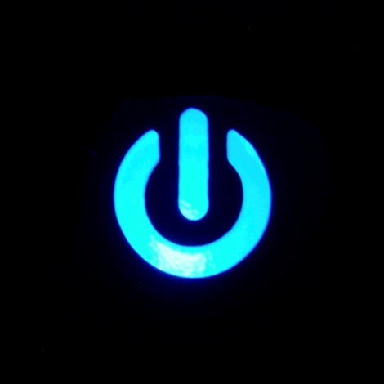

Graphic 1. Interruptor.

Source: xx.

Table 1. Example of table.

A | B | C
1 | 2 | 3
1 | 2 | 3

Source: xx.

4. DISCUSSION AND/OR CONCLUSIONS

Typography: Times New Roman 11, line spacing 1.15.

4.1. SUBTITLE (IF IT IS NECESSARY)

Typography: Times New Roman 11, line spacing 1.15.

5. acknowledgment

Typography: Times New Roman 11, line spacing 1.15.

6. REFERENCES

Typography: Times New Roman 11, line spacing 1.15.

References orderly alphabetically and according to the 7th edition of APA regulations.

